Exercise 1

Write a program to perform matrix multiplication of m x n matrix. Given the condition if number of rows of first matrix equal to the number of rows of the second matrix.

**SOURCECODE:**

#include<iostream>

#include<iomanip>

using namespace std;

int main()

{

//Declaring Variable:

int i,j,k,r1,c1,r2,c2;

//Taking Size Of Matrix A & B By User:

cout<<"Enter size of Matrix A: "<<endl;

cin>>r1>>c1;

cout<<"\nEnter size of Matrix B: "<<endl;

cin>>r2>>c2;

//Declaring Arrays:

int a[r1][c1],b[r2][c2],c[r1][c2],sum=0;

//The Whole Program is Skipped If Column1 is Not Equal to Row2:

if(c1!=r2)

{

cout<<"Matrix Multiplication is not Possible"<<endl;

return 0;

}

cout<<"\nEnter Values Of Matrix A:"<<"\n\n";

//Taking Input Of Matrix A Values from User:

for(i=0;i<r1;i++)

{

for(j=0;j<c1;j++)

{

cout<<"Enter["<<i<<"]["<<j<<"] :";

cin>>a[i][j];

}

}

cout<<"\nEnter Values Of Matrix B:"<<"\n\n";

//Taking Input Of Matrix B Values from User:

for(i=0;i<r2;i++)

{

for(j=0;j<c2;j++)

{

cout<<"Enter["<<i<<"]["<<j<<"] :";

cin>>b[i][j];

}

}

/*Apply Nested For loop To calculate Multiplication Of

Matrix A & B And Store It In Matrix C:*/

for(i=0;i<r1;i++)

{

for(j=0;j<c2;j++)

{

for(k=0;k<r2;k++)

{

sum+=a[i][k]*b[k][j];

}

c[i][j]=sum;

sum=0;

}

}

cout<<"\n Matrix A"<<endl<<"\n";

//Prints Matrix A:

for(i=0;i<r1;i++)

{

cout<<"\t";

for(j=0;j<c1;j++)

{

cout<<setw(4)<<a[i][j];

}

cout<<endl;

}

cout<<"\n Matrix B"<<endl<<"\n";

//Prints Matrix B:

for(i=0;i<r2;i++)

{

cout<<"\t";

for(j=0;j<c2;j++)

{

cout<<setw(4)<<b[i][j];

}

cout<<endl;

}

cout<<"\nMultiplication Of Matrix A & B:"<<endl;

cout<<"\n Matrix C"<<endl<<"\n";

//Prints Multiplication Of Matrix A & Matrix B:

for(i=0;i<r1;i++)

{

cout<<"\t";

for(j=0;j<c2;j++)

{

cout<<setw(5)<<c[i][j];

}

cout<<endl;

}

return 0;

}

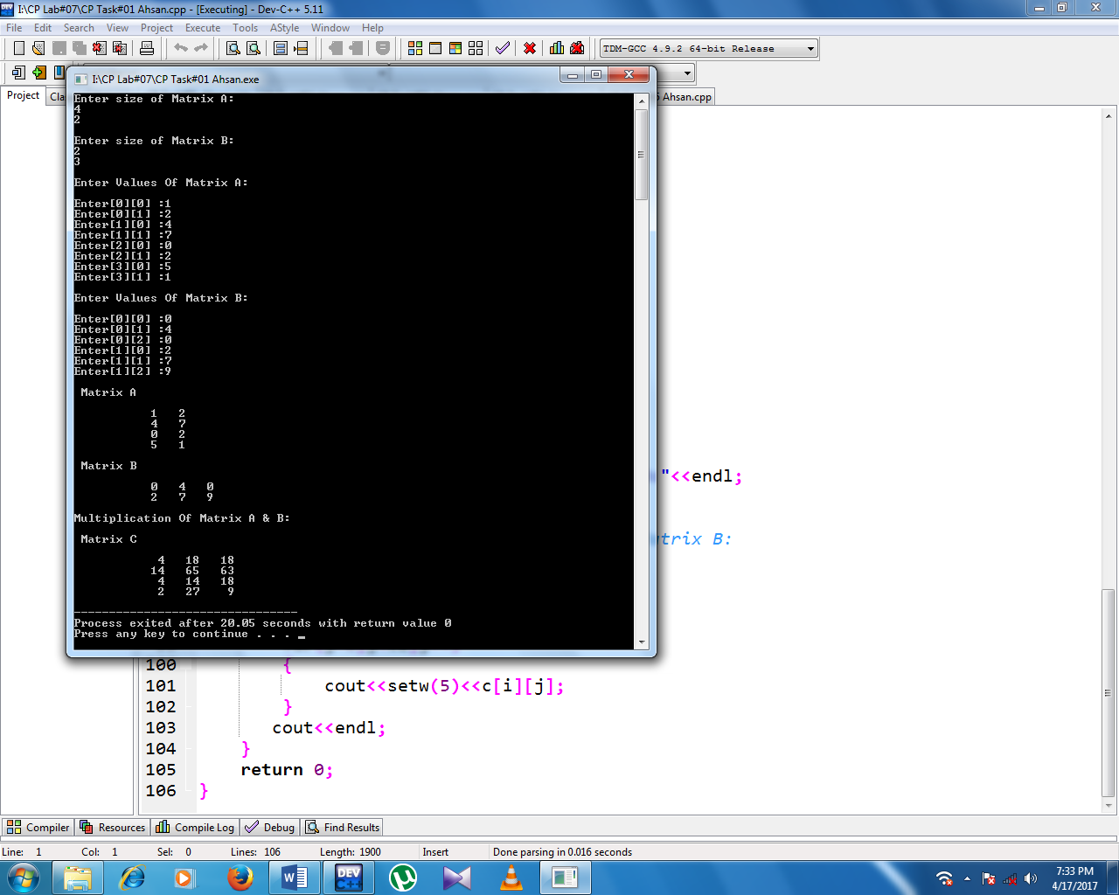**SCREENSHOT:**

Exercise 2

Write a C++ Program that computes the sum of two matrices. Each matrix is of 2 rows and 2 columns and will be created from user input.

Output of the program is as follows:

Enter [0][0] of Matrix A: 2

Enter [0][1] of matrix A: 3

Enter [1][0] of matrix A: 4

Enter [1][1] of matrix A: 5

Enter [0][0] of Matrix B: 6

Enter [0][1] of matrix B: 7

Enter [1][0] of matrix B: 8

Enter [1][1] of matrix B: 9

A = 2 3 + B = 6 7 = C = 8 10

4 5 8 9 12 14

**SOURCECODE:**

#include<iostream>

#include<iomanip>

using namespace std;

int main()

{

//declaring variable:

int i,j,c[2][2],a[2][2],b[2][2];

//Taking input of Matrix A:

for(i=0;i<2;i++)

{

for(j=0;j<2;j++)

{

cout<<"Enter["<<i<<"]["<<j<<"] of Matrix A: ";

cin>>a[i][j];

}

}

//Taking input of Matrix B:

cout<<"\n";

for(i=0;i<2;i++)

{

for(j=0;j<2;j++)

{

cout<<"Enter["<<i<<"]["<<j<<"] of Matrix B: ";

cin>>b[i][j];

}

}

//This loop Prints values of Matrix A:

cout<<"\n"<<"Matrix A="<<endl<<"\n";

for(i=0;i<2;i++)

{

for(j=0;j<2;j++)

{

cout<<setw(5)<<a[i][j];

}

cout<<endl;

}

//This loop Prints values of Matrix B:

cout<<"\n"<<"Matrix B="<<endl<<"\n";

for(i=0;i<2;i++)

{

for(j=0;j<2;j++)

{

cout<<setw(5)<<b[i][j];

}

cout<<endl;

}

//Add Matrix A & Matrix B and Store it in Matrix C:

for(i=0;i<2;i++)

{

for(j=0;j<2;j++)

{

c[i][j]=a[i][j]+b[i][j];

}

}

cout<<"\n"<<"Addition Of Matrix A & B is:"<<endl;

cout<<"\n"<<"Matrix C="<<endl<<"\n";

//Print Matrix C:

for(i=0;i<2;i++)

{

for(j=0;j<2;j++)

{

cout<<setw(5)<<c[i][j];

}

cout<<endl;

}

return 0;

}

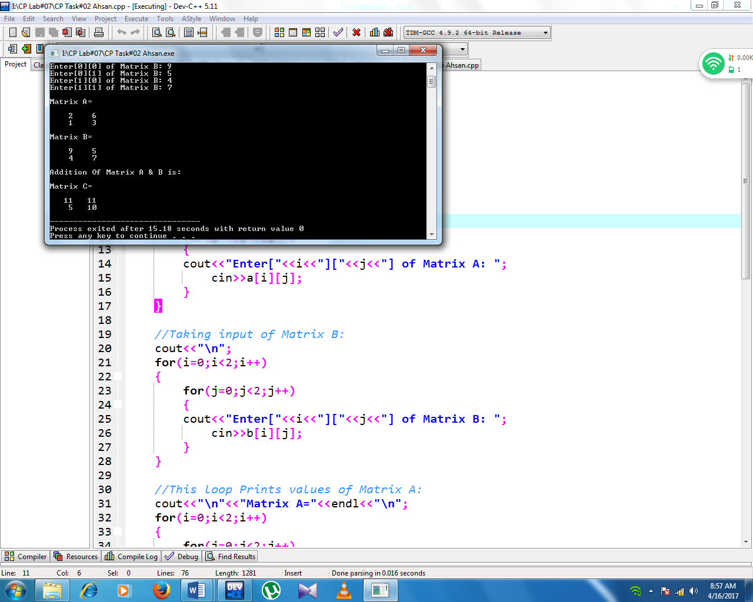**SCREENSHOT:**

Exercise 3

Write a C++ program to calculate the result of three sections of a semester. Following are the rules for result:

1. Three are 3 sections.
2. Each section has 8 students.
3. Each student takes 5 courses.

Marks for each subject of every student of each section must be taken from the user.

Calculate the result of every student of each section as follows:

1. Obtained marks (Sum of all courses marks). Max. marks of each subject are 100
2. Percentage

**SOURCECODE:**

#include<iostream>

#include<iomanip>

using namespace std;

int main()

{

// SECTION A:

//Declaring variables:

int i,j,a[8][5],sum,per;

cout<<"\t\t\t"<<setw(30)<<setfill('*');

cout<<"\n\t\t\t"<<" SECTION A"<<endl;

cout<<"\t\t\t"<<setw(28)<<setfill('*')<<"\n\n";

//Apply nested for loop to input values of multi-dimension array:

for(i=0;i<8;i++)

{

for(j=0;j<5;j++)

{

//Taking input of each student courses marks:

cout<<"Marks of Student "<<i+1<<" in course "<<j+1<<": ";

cin>>a[i][j];

}

cout<<"\n";

}

/*Apply neste for loop to add rows of array in sum and then

calculate percentage of sum:*/

for(int i=0;i<8;i++)

{

for(int j=0;j<5;j++)

{

//Calculate sum & percentage(%) of courses total marks:

sum=sum+a[i][j];

per=sum*100/500;

}

//Output the obtained marks & percentage of each student:

cout<<"Obtained Marks Of Student "<<i+1<<": "<<sum<<endl;

sum=0;

cout<<"Percentage(%) Of Student "<<i+1<<": "<<per<<"%"<<endl;

per=0;

cout<<"\n";

}

// SECTION B:

//Declaring variables:

int b[8][5];

cout<<"\t\t\t"<<setw(30)<<setfill('*');

cout<<"\n\t\t\t"<<" SECTION B"<<endl;

cout<<"\t\t\t"<<setw(28)<<setfill('*')<<"\n\n";

//Apply nested for loop to input values of multi-dimension array:

for(i=0;i<8;i++)

{

for(j=0;j<5;j++)

{

//Taking input of each student courses marks:

cout<<"Marks of Student "<<i+1<<" in course "<<j+1<<": ";

cin>>b[i][j];

}

cout<<"\n";

}

/*Apply neste for loop to add rows of array in sum and then

calculate percentage of sum:*/

for(int i=0;i<8;i++)

{

for(int j=0;j<5;j++)

{

//Calculate sum & percentage(%) of courses total marks:

sum=sum+b[i][j];

per=sum*100/500;

}

//Output the obtained marks & percentage of each student:

cout<<"Obtained Marks Of Student "<<i+1<<": "<<sum<<endl;

sum=0;

cout<<"Percentage(%) Of Student "<<i+1<<": "<<per<<"%"<<endl;

per=0;

cout<<"\n";

}

// SECTION C:

//Declaring variables:

int c[8][5];

cout<<"\t\t\t"<<setw(30)<<setfill('*');

cout<<"\n\t\t\t"<<" SECTION C"<<endl;

cout<<"\t\t\t"<<setw(28)<<setfill('*')<<"\n\n";

//Apply nested for loop to input values of multi-dimension array:

for(i=0;i<8;i++)

{

for(j=0;j<5;j++)

{

//Taking input of each student courses marks:

cout<<"Marks of Student "<<i+1<<" in course "<<j+1<<": ";

cin>>c[i][j];

}

cout<<"\n";

}

/*Apply neste for loop to add rows of array in sum and then

calculate percentage of sum:*/

for(int i=0;i<8;i++)

{

for(int j=0;j<5;j++)

{

//Calculate sum & percentage(%) of courses total marks:

sum=sum+c[i][j];

per=sum*100/500;

}

//Output the obtained marks & percentage of each student:

cout<<"Obtained Marks Of Student "<<i+1<<": "<<sum<<endl;

sum=0;

cout<<"Percentage(%) Of Student "<<i+1<<": "<<per<<"%"<<endl;

per=0;

cout<<"\n";

}

return 0;

}

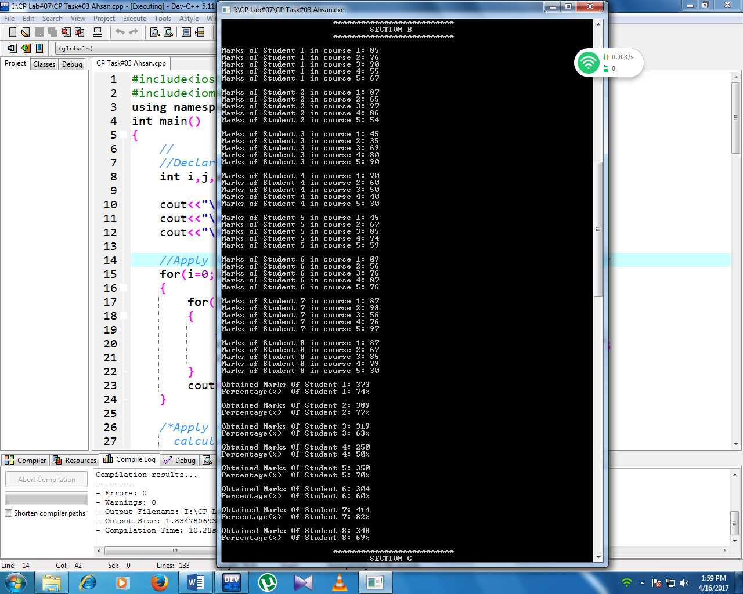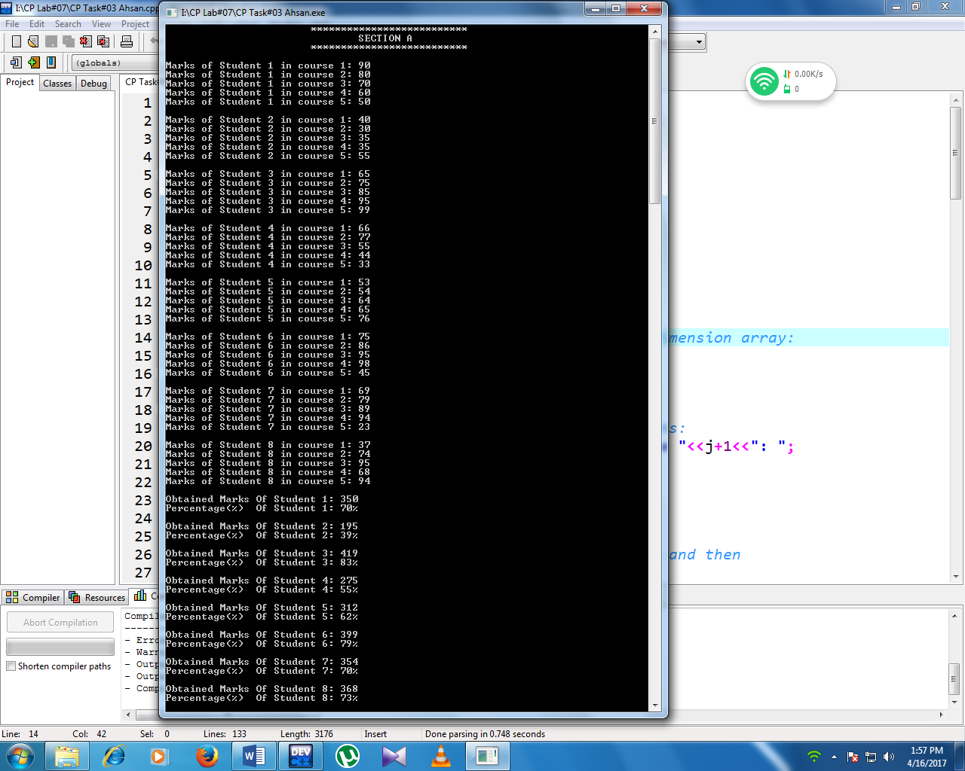**SCREENSHOTS:**

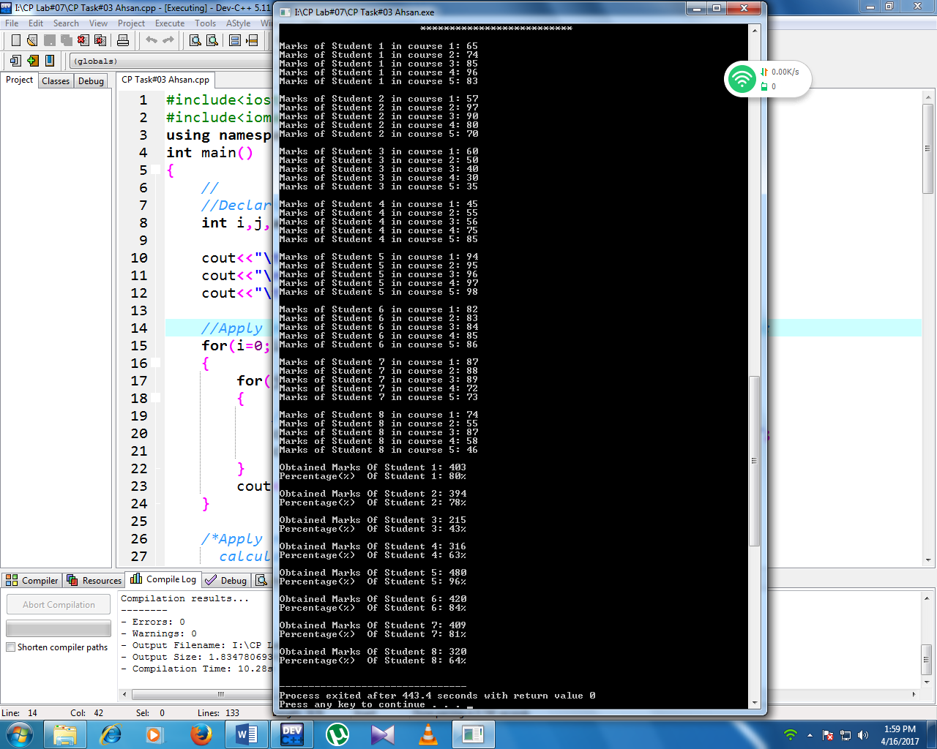

Exercise 4

Write a C++ program, that read 12 integer values from user, store values in Matrix of 4 X 3. Create another Matrix of 4 X 3, divide each element of Matrix1 by five, and store the result in the Matrix2.

Print Matrix A, with heading shown, correctly spaced.

Print Matrix B, with heading shown, correctly spaced.

**SOURCECODE:**

#include<iostream>

#include<iomanip>

using namespace std;

int main()

{

//Declaring Variable:

int a[4][3],b[4][3],i,j;

cout<<"Enter any 12 integer values of an Array:"<<endl;

//Values of array entered by user:

for(i=0;i<4;i++)

{

for(j=0;j<3;j++)

{

cin>>a[i][j];

}

cout<<setw(3);

}

cout<<"\n"<<"============================="<<endl;

cout<<setw(4)<<"Matrix A-Original"<<endl;

cout<<"============================="<<endl;

//Output of array1 in Matrix form:

for(i=0;i<4;i++)

{

for(j=0;j<3;j++)

{

cout<<setw(5)<<a[i][j];

}

cout<<endl;

}

//Array1 divided by 5 and then store in array2:

for(i=0;i<4;i++)

{

for(j=0;j<3;j++)

{

b[i][j]=a[i][j]/5;

}

cout<<endl;

}

cout<<"============================="<<endl;

cout<<setw(4)<<"Matrix A-Divided by 5"<<endl;

cout<<"============================="<<endl;

//output of array2 in Matrix form:

for(i=0;i<4;i++)

{

for(j=0;j<3;j++)

{

cout<<setw(4)<<b[i][j];

}

cout<<endl;

}

return 0;

}

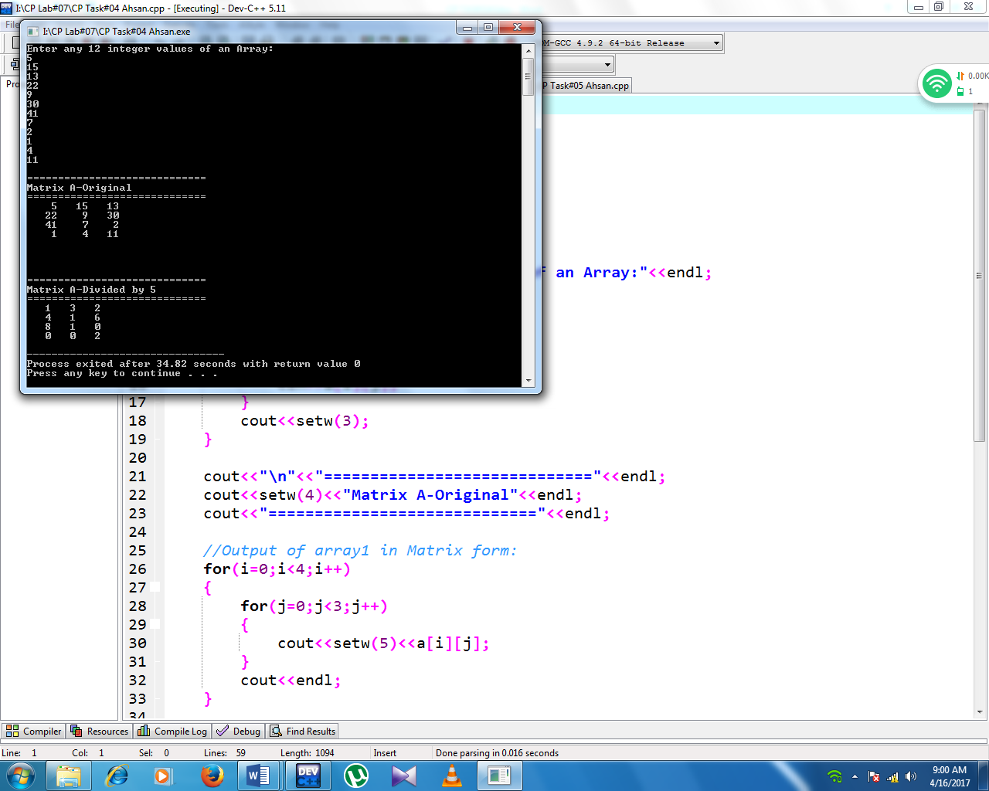**SCREENSHOT:**

Exercise 5

Write a C++ program to calculate the sum of each row and colum of a two-dimensional (2D) array of size RxC. for example:

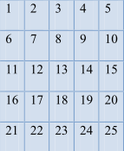

Your Program should display output as follows:

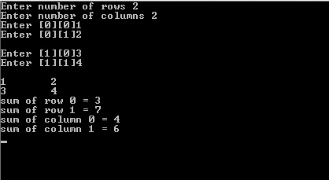**Sum**

**SOURCECODE:**

#include<iostream>

#include<iomanip>

using namespace std;

int main()

{

//Declaring Variable:

int ro,co,i,j;

//Taking Size of an Array from User:

cout<<"Enter rows of an Array: ";

cin>>ro;

cout<<"Enter columns of an Array: ";

cin>>co;

int a[ro][co],rosum=0,cosum=0;

cout<<"\n";

//Taking input of array1 Values from user:

for(i=0;i<ro;i++)

{

for(j=0;j<co;j++)

{

cout<<"Enter["<<i<<"]["<<j<<"] :";

cin>>a[i][j];

}

}

cout<<"\n";

//Prints Array1 in Matrix form:

for(i=0;i<ro;i++)

{

for(j=0;j<co;j++)

{

cout<<" "<<a[i][j];

}

cout<<endl;

}

cout<<"\n";

//Add Rows of Array1 & also prints the row sum:

for(i=0;i<ro;i++)

{

for(j=0;j<co;j++)

{

rosum+=a[i][j];

}

cout<<"sum of Row "<<i<<"= "<<rosum;

rosum=0;

cout<<"\n";

}

cout<<"\n";

//Add Columns of Array1 & also prints the Column sum:

for(j=0;j<co;j++)

{

for(i=0;i<ro;i++)

{

cosum+=a[i][j];

}

cout<<"sum of Column "<<j<<"= "<<cosum;

cosum=0;

cout<<"\n";

}

return 0;

}

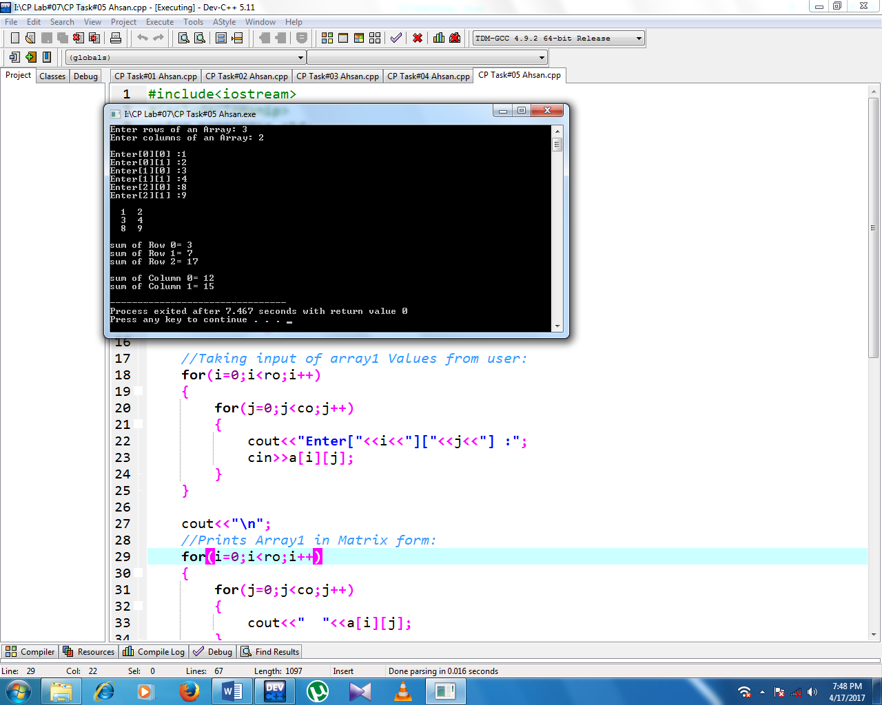**SCREENSHOT:**